Design and implementation of Electric Wheelchair
With Controlling the speed & movement of wheelchair
Prof. S. S. Kumbar^{#1}, , Mr Sandeep Mudakannavar^{#2}, Mr Vinayak patil
#Electrical Department, SGI-Atigre, Shivaji University
Maharashtra, India
¹kumbar.ss@sginstitute.in
²Mudakannavar.ss@sginstitute.in
³vinayakpatil235@gmail.com

Abstract— Differently disabled people face many hardships in life, having to be dependent on a third person to move from place to place. The electric wheelchair is an implementation and experimental platform of a low-cost intelligent wheelchair for the disabled. To provide them with a supporting aid, many scientists have been toiling for a long time. The invention of wheel chair is a great boon to them but it still restricts their motion. This project aims at providing them with a non-polluting and cost effective solution in the form of an Electric Wheel Chair.

Key words: Wheel chair, Hub motor, Battery, Turning Mechanism
- Introduction
In society we all see handicapped people. They are facing so many difficulties during their day to day life. They always need help from others. They are not independent. Our purpose of doing this project is to help them in such a manner that they can feel independent. To accommodate this population, several researchers have used technologies originally developed for mobile robots to create “smart wheelchairs.” A smart wheelchair typically consists of either a standard power wheelchair to which a computer and a collection of sensors have been added or a mobile robot base to which a seat has been attached. Smart wheelchairs have been designed that provide navigation assistance to the user in a number of different ways, such as assuring collision-free travel, aiding the performance of specific tasks (e.g., passing through doorways), and autonomously transporting the user between locations.

II. OBJECTIVES
The aim of this project was to design an Electric wheelchair as follows:
- To fabricate affordable Electric wheelchair)
- To provide smooth speed & movement control

To make the project as cost effective & less weight as compared to other conventional methods.

III. Block Diagram
The system block diagram shows how the supply from battery is sent to motor through controller. Speed is controlled by accelerator.
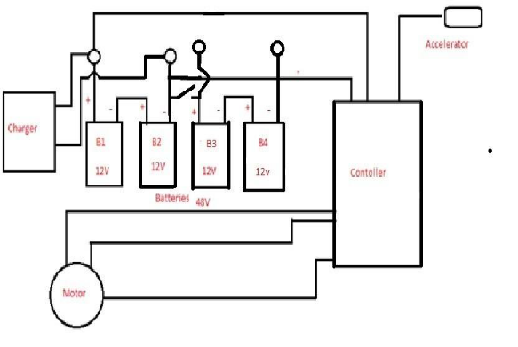
Fig.1 Block diagram showing flow of supply in the EWC

IV.EQUIPMENTS AND TECHNIQUES
For this project to be built both electrical & electronics components were required. Some of the parts are briefly described as follows:
Hub Motor: Most 250 watt motors are geared hub motors, meaning they have a planetary gear reduction so that the motor spins at an optimal RPM. This makes the motor more efficient than a simpler direct drive hub motor. At 250 watts, the planetary gears mean a torque and more efficient motor. In this motor pictured below, you can see the planetary gears which allow the motor to spin up to 5 times faster than the wheel. Since electric motors love fast RPMs (more efficient, more torque, and more reliable) the planetary gear allows the use of a smaller and lighter motor, with the same power output of a larger motor. Power to weight, the geared hub motor is much better than a direct drive hub motor. Although a few companies make a 250 watt direct drive motor (such as Bionx’s 250 watt motor, the same motor that goes on the Smart Bike), we strongly suggest that if you buy a bike with this size of motor that you opt for the geared hub motor which is lighter, smaller and more efficient than its direct drive counterpart. Like most hub motors of today, most of the 250 watt motors currently on the marketplace use highly efficient brushless motors.

V. special features

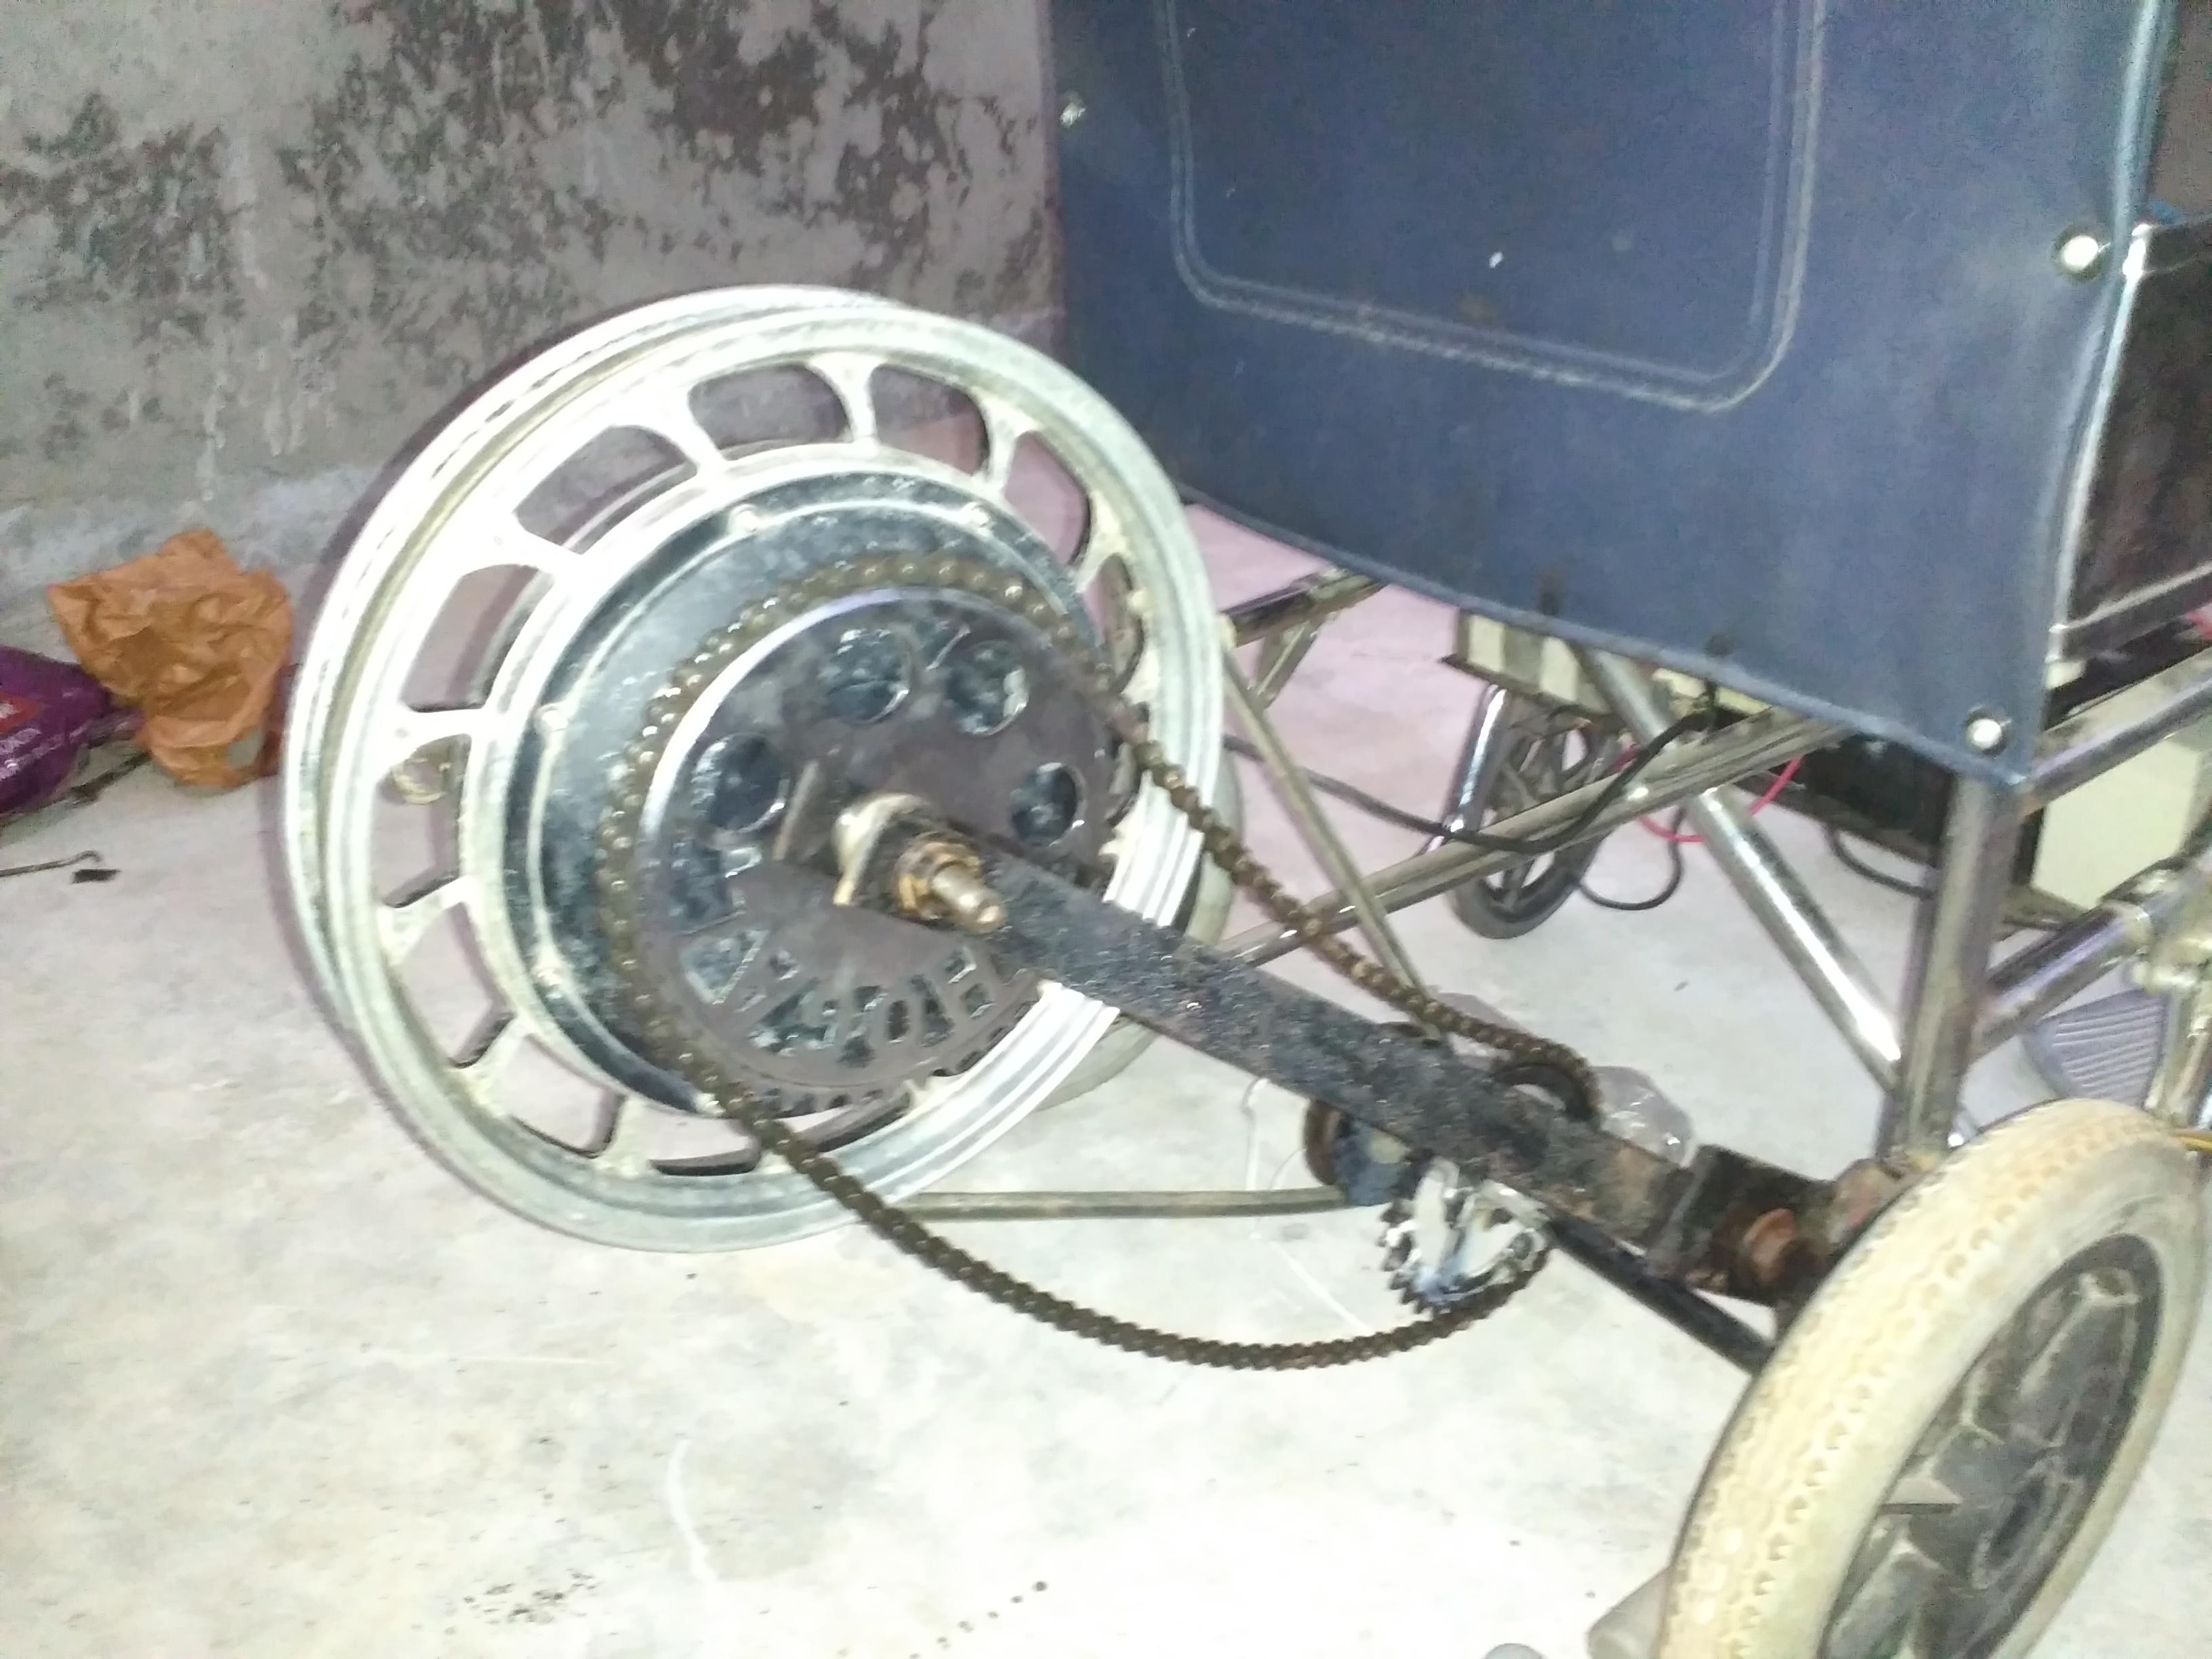
Fig.2 Design of Wheel chair

Special features

- Total weight of wheelchair- <30kg (Including Hub motor, Wheelchair, batteries)
- Support heavy load – 100kg
- Maximum Speed- 15Km/hr
- Maximum distance till battery gets discharge – 20km
- Battery discharge time – 1hr 15 min.
- Well designed frame for comfortable riding
- Pollution free
- Safe, reliable, light weight(<30kg)
- High efficiency to brushless hub motor
- Break through brushless drive technology
- Cost effective

VI. Comparison
Sr. no | Parameter | Electric wheel chair | Market wheel chairs
1. | Weight | Light weight (<30kg) | Heavy weight (>30kg)
2. | Automation | Semi-automatic | Automatic
3. | Working time | 1hr 15 min. | 1hr. (Excluding other operations)
4. | Design | Simple | Complicated
5. | Space | Less | More
6. | Noise | Noiseless | Noisy
7. | Overall efficiency | 70%- 75% | 80% & Above
8. | Cost | Low Cost | High cost

VII. Limitations
This project is for persons who are handicapped by legs only. The person who is fully handicapped cannot use this electric wheelchair. This project is semi automatic. Mechanical break is used for braking so friction losses are more. Frequent replacement of brush shoe is required.

VIII. Future Scope
There are plenty of scope to upgrade this EWC project by making it fully automatic by adding features like voice & gesture recognition which provides ease of operation in this system that will be more users friendly. GPS tracking to find out user exact location. There are scopes to use solar panel for battery charging to support renewable energy scheme.

IX. conclusion
This EWC resulted into successful project which is cost effective & light weight. This minimized expense is pretty affordable for most of the medium class people & it can be even cheaper when taken for mass production.
This project can also be counted as a brilliant initiative for the betterment of physically handicapped & disabled people’s lifestyle.

X. REFERENCES
- Humaria Salmin, Hafiz Rakibul, Pratik Kumar Kundu, B.M. Fahmid Jahur Shuvo, K.B.M Nasiruzzaman & Rahman MD. Moshiour (Feb.2014), International Journal of multidisplinary science& Engineering.

- PreethikaBritto, Indumathi.J, Sudesh Sivarasu (2010), “Automation of wheelchair using ultrasonic and body kinematics”, National Conference Computational Instrumentation.

- Jobby K. Chacko, DeepuOommen, Kevin K. Mathew, Noble Sunny, N. Babu

- Richard Simpson, “The Smart Wheelchair Component System”

- http://people.ece.cornell.edu/land/courses/ece4760/labs/f2013/lab4.html

